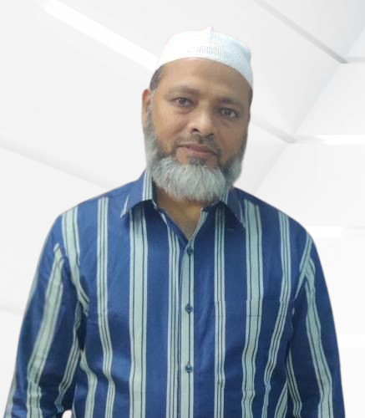
Mohammed Abdul Haneef Siddiqui
Des Plaines, IL 60016
+1 2245378011
Email: haneef_siddiqui@yahoo.com

Professional Summary
Experienced HVAC Installer proficient in the operations and repairs of heating, refrigeration, ventilation, and air conditioning systems. Efficiency-driven, highly accurate, and well-organized with an open and clear communication style and a self-motivated approach. Dedicated to superior service and solving problems with minimal oversight.

Technical Skills
- HVAC System Installation and Repair
- Troubleshooting and Problem Solving
- Knowledge of Local Codes and Regulations
- Electrical Wiring and Control Systems
- Control systems
- System maintenance
- Preventive Maintenance
- Piping systems
- Equipment installation
- Air balancing
- Filter replacement
- Refrigeration systems
- Customer Service Excellence
- Equipment installation
- Safety and Hazardous Material Handling

Indian Government Certification
SETWIN
SOCIETY FOR EMPLOYMENT PROMOTION & TRAINING IN TWIN CITIES, A GOVT. OF ANDHRA PRADESH SOCIETY, HYDERABAD (INDIA)

ILLINOIS Diver’s License

Professional Details
- Total Work Experience: 10+ years
- Current Industry: HVAC /Air Conditioning / Refrigeration
- Current Functional Area: Installation / Maintenance / Operations / Repair
- Current Work Level: Management and Non-Managerial Level
- Availability to Join: Immediately

Professional Experience
Air Conditioning Technician
Ministry of Endowments, Dafna, Doha
01/1995 - 10/2024
- Worked closely with colleagues to complete projects within established timelines.
- Ensured proper disposal of hazardous materials used during repairs or installations.
- Kept current with all applicable local codes related to installation standards for air conditioners.
- Assessed system operations to identify potential areas requiring maintenance services.
- Updated and maintained service records and documentation for all HVAC maintenance and repair activities.
- Calibrated thermostats to meet specific temperature requirements for clients.
- Conducted regular system inspections and preventative maintenance tasks, reducing system downtime and repair costs.
- Loaded materials, tools, and equipment on the truck at the beginning of each shift.
- Reviewed work orders and discussed with supervisors.
- Replaced defective components in air conditioning systems to ensure optimal performance.
- Installed, maintained, and repaired air conditioning, heating, ventilation, and refrigeration units in homes, commercial buildings, and large industrial complexes, completing projects on schedule.
- Responded to customer inquiries and complaints, providing timely and effective solutions to HVAC issues.
- Planned work procedures using charts, technical manuals, and experience.
- Maintained accurate records of all work performed in accordance with company guidelines.
- Completed preventive maintenance on heating and air conditioning systems to extend the life of such equipment.
SOFT SKILLS
- Communication and Team Collaboration.
- Analytical Skills & Critical Thinking.
- Problem-solving abilities.
- Professionalism & Attention to Detail.
- Adaptability & Flexibility.
- Attention to Detail
- Time Management
- Conflict Resolution
- Honest and Smart working.
ENTREPRENEURIAL MINDSET
- Proactive thinker with innovative problem-solving skills and a drive for continuous improvement.
- Passionate about exploring new ideas and embracing challenges in dynamic environments.
- Committed to embracing challenges and continuously seeking ways to create value and drive success.

PERSONAL DETAILS
Name : Mohammed Abdul Haneef Siddiqui
Nationality : Indian
Date Of Birth : 13-03-1972
Religion : Islam
Marital Status : Married
Languages Known : English, Arabic, Hindi, Urdu & Telugu
Email : haneef_siddiqui@yahoo.com
Mob : +1 2244699448

DECLARATION
I hereby declare that all the above-mentioned information is correct to the best of my knowledge.

